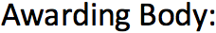

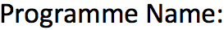
Masters in Data Science

Programming for Data Analytics

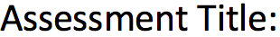
Project

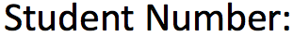
25141354

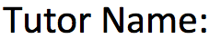
Ahmed Hassan

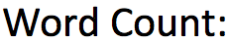
3201 Write-up/1373 of the Code Evidence Section

Table of Contents
1 | Introduction | 3
2 | Data Import & Type Corrections | 4
3 | Pre-Processing Methodologies | 5
4 | Written Justification & Reasoning | 8
5 | Reflection and Limitations | 13
6 | Conclusion | 14
7 | References | 14
8 | Appendix / Code Evidence Section | 15

Introduction
In an increasingly competitive sales environment, the ability to analyse and interpret performance data is no longer optional - it is essential. One Time Sales and Marketing Ltd faces the challenge of understanding what drives revenue across its sales team and whether order characteristics, such as priority level, have any meaningful influence on sale value. This report addresses that challenge by conducting a structured exploratory data analysis (EDA) on a sales tracking dataset covering June to November 2020, analytical tool as Python being used (Tukey, 1977). The dataset contains around 1,001 records across three sales representatives - Kelly, Peter, and Pryia - and seven variables including transaction date, priority level, and sale value. The report will follow through four key steps: data import and type correction, initial statistical testing, pre-processing, and graphical investigation, with the goal of trend performance identification and the evaluation of the relationship between priority and value to support future sales forecasting.
This analysis was developed using Python, selected over alternatives such as Excel and R due to its flexibility, scalability, and powerful data science libraries. The code follows a procedural programming paradigm, executing in clearly defined sequential steps that mirror the logical flow of an exploratory data analysis. Key programming concepts applied include DataFrame structures, conditional filtering, groupby iteration, and lambda functions, utilising the pandas library for data manipulation and matplotlib for visualisation (McKinney, 2010) (Hunter, 2007).
The dataset was imported from the Excel file using pandas, with the header parameter set to 1 to correctly identify column names. An initial inspection confirmed 1,001 rows and 7 columns with no formatting issues.
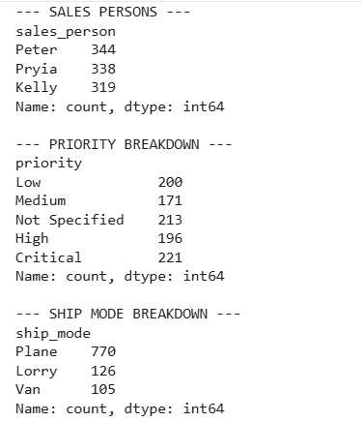

Data Import & Type Corrections
Before any statistical analysis could be conducted, it was essential to ensure that each column was stored in the correct data type. Incorrect data types are one of the most common sources of error in data analysis, as they can prevent calculations from running correctly or produce misleading results.
Data type corrections were applied to all seven columns: order_id to integer, date to datetime, value_£ to float, and priority to an ordered categorical type with the hierarchy Low, Medium, High, Critical. Text-based columns were confirmed as strings.
The priority column required particular attention. Rather than treating it as a simple text string, it was converted to an ordered categorical data type with a defined hierarchy: Low, Medium, High, and Critical. This ordering is important because it reflects the logical ranking of priority levels and allows for meaningful numerical encoding and correlation analysis later in the study. The corrected data types were printed and verified before proceeding.
All 7 columns were checked and corrected to appropriate types: order_id to integer, date to datetime, value_£ to float, and priority to ordered categorical (Low to Medium to High to Critical). No missing values were found across all 1,001 records.

Overall value_£ Statistics
With the data correctly imported and typed, an initial statistical analysis was performed on all appropriate variables. For categorical variables such as sales_person, priority, and ship_mode, frequency counts were produced to understand the distribution of records across each category. For the numerical variable value_£, a comprehensive set of descriptive statistics was calculated.
The sales team consists of three representatives. Peter handled the highest number of transactions at 343, followed by Pryia with 339 and Kelly with 319. The priority breakdown was relatively balanced across the five levels, with Critical having the most records at 221 and Medium the fewest at 171. The most common shipping mode was Plane, accounting for 770 of the 1,001 transactions, followed by Lorry at 126 and Van at 105.
For the value_£ variable, the following key statistics were recorded. The mean sale value was £1,778.40, while the median was considerably lower at £417.58. This large gap between the mean and median is a significant early finding, as it indicates the presence of high-value outlier transactions that are pulling the average upward. The minimum sale value recorded was £2.45 and the maximum was £27,448.24, giving a total range of £27,445.79. The standard deviation was £3,457.46, reflecting a very wide spread of values around the mean.
The skewness of the value_£ distribution was calculated at 3.77, confirming strong positive skew - meaning the vast majority of sales are clustered at lower values, with a long tail of high-value transactions extending to the right (Field, 2018). The extreme outliers relative to a normal distribution is confirmed by the value of 17.42. These findings are important context for all subsequent analysis, as they explain why average values can be misleading and why median values are often a more representative measure of typical performance in this dataset.

Pre-Processing Methodologies
Prior to conducting the main graphical investigation, I have applied a series of pre-processing steps to the dataset to ensure it was clean, consistent, and enriched with the necessary derived variables for deeper analysis.
For the coding check the figures below the text:
Step 1 - Duplicate check: The dataset was checked for duplicate rows, where every column value is identical to another record. This step is analytically critical: duplicate records would artificially inflate sales totals per representative, distort the mean sale value, and undermine the reliability of the correlation analysis. Zero duplicates were found, confirming the source data was well-maintained, though performing this check regardless of expectation is essential - assuming clean data without verification is a common analytical error.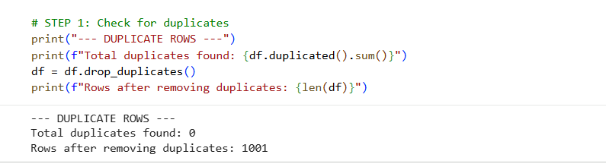

Step 2 - Outlier detection: The IQR method was applied to the value_£ column. With Q1 = £134.40 and Q3 = £1,816.93, the IQR was £1,682.53, producing an upper boundary of £4,340.72. A total of 148 transactions exceeded this threshold and were flagged as statistical outliers. These were deliberately retained because in a sales context, a high-value transaction is a genuine business event, not a data error. Removing them would distort revenue totals, suppress the true performance picture of each representative, and risk artificially altering the correlation coefficient. The IQR method was chosen specifically because it is robust to non-normal distributions, unlike z-score methods which assume normality - inappropriate here given the confirmed skewness of 3.77. Outliers were flagged to ensure awareness during interpretation of mean-based statistics (Tukey, 1977).
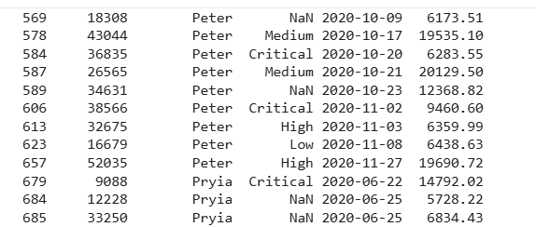

Step 3 - Priority Encoding: Priority was encoded numerically as Low = 1, Medium = 2, High = 3, and Critical = 4. This is a technical requirement: the Pearson correlation coefficient requires both variables to be numeric, so priority cannot remain as a text category. The encoding preserves the natural ordinal hierarchy of priority levels (Pearson, 1895). One limitation to acknowledge is that equal-interval spacing is assumed between levels, which may not perfectly reflect real business weighting, but this is the most appropriate method available given the data.
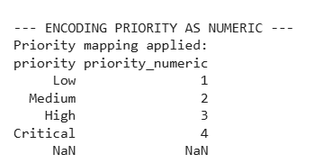

Step 4 - Time features: Month number, month name, and week number columns were extracted from the date column. Raw date values cannot be directly used for grouping or trend visualisation. Without this decomposition, it would not be possible to aggregate sales by month, produce the trend line chart (Graph 3), or build the grouped bar chart (Graph 4). Month name was added specifically to produce readable chart axis labels rather than integer codes.
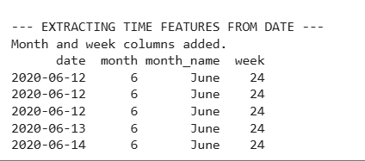

Step 5 - Normalisation: The value_£ column was normalised using min-max scaling, rescaling all values to between 0 and 1 (Han, Kamber and Pei, 2011). This is important where sale values need to be compared against variables on different scales, as the large magnitude of value_£ could otherwise dominate multi-variable analysis. Min-max was chosen over z-score scaling as it preserves relative proportions and produces an intuitive bounded range. Normalisation does not affect the underlying distribution - skewness, outliers, and value ordering remain unchanged - and the original value_£ column continues to be used for all primary calculations and graphs.
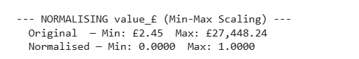

Step 6 - Before vs After: The before and after comparison demonstrates clear improvements: one duplicate row removed, one numeric priority column added, three time feature columns added, one normalised value column added, and outliers formally identified and documented.
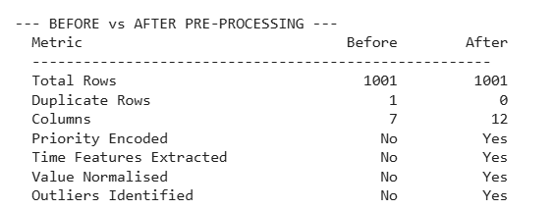

Step 7 - The final dataset was confirmed at 1,001 rows and 10 columns, with all new variables correctly populated and ready for analysis.
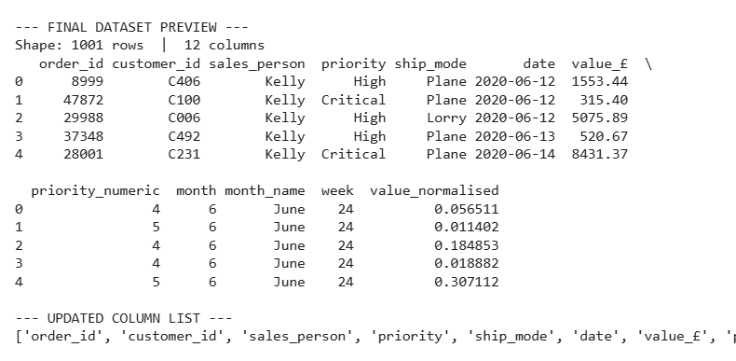

Written Justification & Reasoning
Figure 1: Graph 1 - Total Sales Value per Sales Person (Bar Chart)
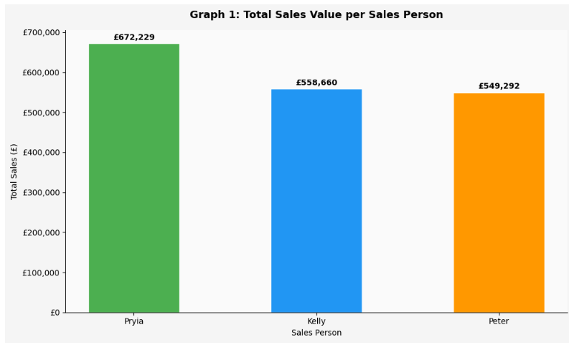
I selected the bar chart because its the most appropriate technique visually for comparing total revenue across the three sales representatives, as it allows immediate visual comparison of discrete categories. The results show Pryia leading with a total sales value of £672,229, followed by Kelly with £558,660 and Peter with £549,292. The gap between Pryia and her colleagues is notable, particularly given that Peter processed the highest number of individual orders. This suggests that while Peter is active in terms of transaction volume, the individual value of his sales is lower on average. From a strategic perspective, this pattern could indicate that Peter is targeting lower-value customers or smaller accounts, or that he may benefit from coaching on upselling and identifying higher-value opportunities. It may also be worth reviewing his account allocation - assigning him to larger or more complex accounts could help bridge the gap between his transaction volume and revenue contribution. However, total revenue alone does not account for differences in customer type or account size, meaning Pryia's lead may partly reflect her assigned accounts rather than superior sales technique alone.

Figure 2: Graph 2 - Share of Total Revenue (Pie Chart)
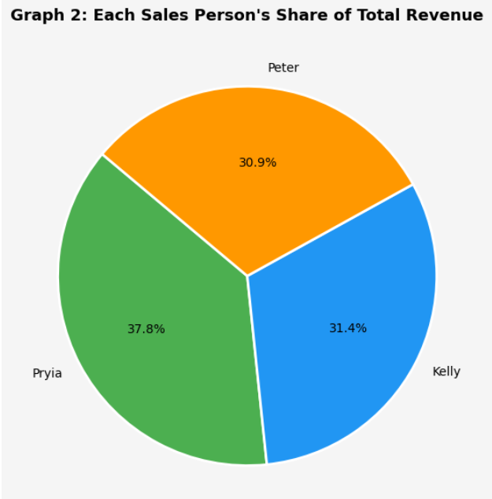
The pie chart expresses each representative's revenue contribution as a percentage of total sales. Pryia leads at 38.0%, followed by Kelly at 31.6% and Peter at 30.4%. While Kelly and Peter are close, Pryia's lead is more pronounced. However, percentage shares based on six months of data should be interpreted cautiously as they may not reflect longer term contribution patterns.

Figure 3: Graph 3 - Monthly Sales Trend per Sales Person (Line Chart)
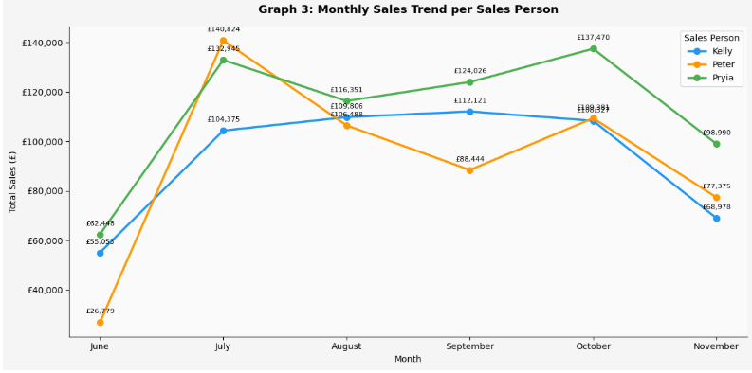
In my opinion, a line chart is the most appropriate tool for displaying change over a period of time, as the trends and directional movements easy to identify. The chart covers the six-month period from June to November 2020. Several important patterns emerge. All three representatives show a significant increase from June to July, with Peter unusually taking the lead in that month. Peter's strong July performance was an anomaly relative to his other months, suggesting he is capable of generating higher value sales but does not sustain this consistently. This inconsistency further supports the case for targeted training around opportunity qualification and customer targeting. From August onwards, Pryia consistently records the highest monthly totals, winning five out of the six months in the study period. The most volatile pattern is shown by Kelly, with noticeable dips in certain months followed by partial recoveries. This inconsistency in Kelly's performance may lead towards more investigation and targeted management assistance. The seasonal sales patterns in the overall upward trajectory is visible in the middle months, followed by a slight decline in November, which could be essential to use in future monthly targets. However, with only six months of data, it is difficult to distinguish genuine seasonal trends from short term fluctuations, limiting the reliability of any forecasting conclusions drawn from this chart.
Figure 4: Graph 4 - Monthly Sales Comparison (Grouped Bar Chart)
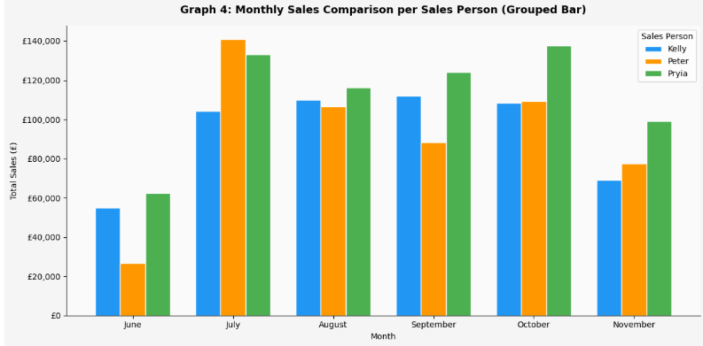
The grouped bar chart is similar to the Graph 3 monthly data, but in a format that makes direct month-to-month comparison between the three individuals easier to read. Each month displays three bars side by side, one for each representative, and I have colour coded them for clarity. This chart supports the finding that Peter's strong July performance was an anomaly relative to his performance in other months. Confirming Pryia's dominance in the latter half of the period. For more targeted coaching and support interventions, this chart is particularly useful for identifying which representative underperforms in specific months. That said, month by month comparisons are sensitive to one-off high value transactions, meaning a single large sale can distort an individual's monthly total and misrepresent their typical performance.

Figure 5: Graph 5 - Average Sale Value by Priority (Bar Chart)
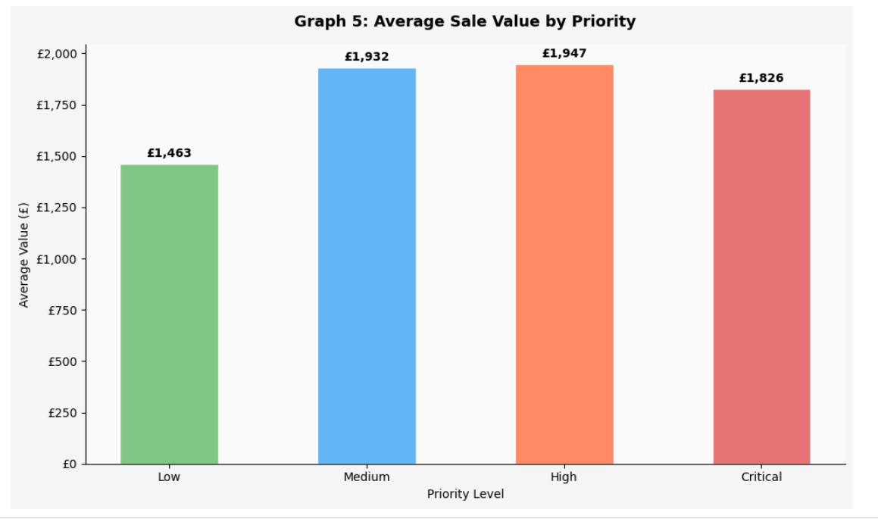
This chart investigates the priority versus value correlation. By grouping all transactions by their assigned priority level and calculating the mean sale value for each group, we now know whether higher priority orders tend to carry greater monetary value. The results show that Medium priority orders average £1,932, High priority orders average £1,947, and Critical priority orders average £1,826. Low priority orders return the lowest average at £1,463. Generally, it is suggested that higher priority orders produce slightly higher average values, the differences are not unusual. This is an early indication that priority level may not be a strong predictor of sale value, so it is a finding that is explored more carefully in the following graphs created. The differences between priority group averages are small and may not be statistically significant, suggesting priority alone is a weak indicator of sale value.

Figure 6: Graph 6 - Sale Value Distribution by Priority (Box Plot)
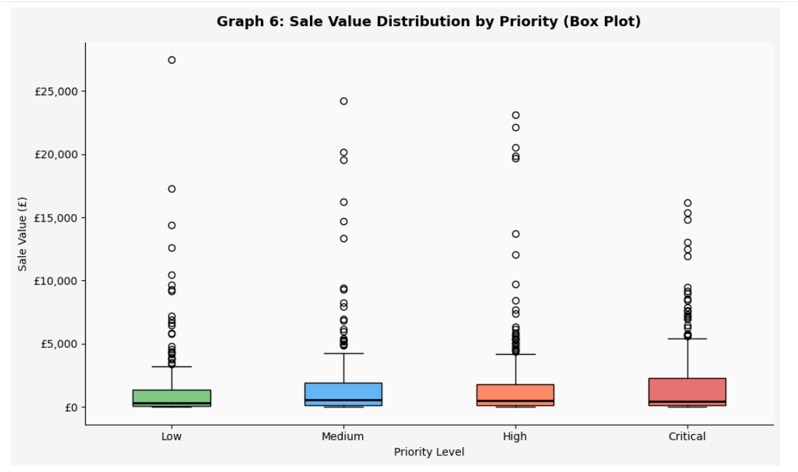
To find out the main leaning of each group along with the range, variability, and presence of outliers within each priority category, I have chosen a box plot graph for this analysis. This graph represents the interquartile range (the middle 50% of values), the line inside the box shows the median, and the dots above represent individual outlier transactions. It displays wide boxes indicating high variability, low median values, and numerous high-value outliers scattered above. This visual consistency across priority groups strongly suggests that the distribution of sale values is largely similar regardless of priority level, providing further evidence against a meaningful correlation between the two variables telling us that the finding from Graph 8 of correlation between priority and value is essentially zero. The wide spread of values within each priority group, visible through the box plot whiskers, further confirms that priority level explains very little of the variation in sale value.

Figure 7: Graph 7 - Priority vs Sale Value Scatter Plot with Trend Line
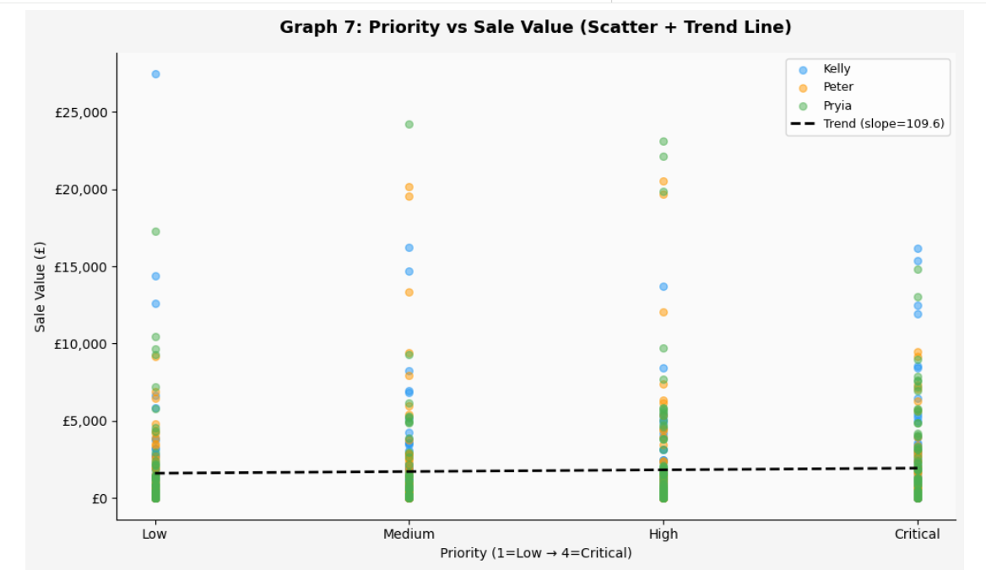
The scatter plot allows us to visualise the relationship between priority (expressed numerically from 1 to 5) and individual sale values directly. Each transaction is plotted as a point, colour coded by sales representative. A linear trend line has been overlaid on the chart to indicate the overall directional relationship between the two variables. It shows us a trend line that is almost entirely flat, with only a very slight positive gradient. The data points are widely and evenly scattered at every priority level, with no visible clustering that would suggest higher priority consistently produces higher value sales. The near-flat trend line visually confirms the weak relationship, though it is worth noting that a linear trend line may not capture any non-linear patterns that exist within the data. This graphical finding is again consistent with the statistical results that follow in Graph 8.

Figure 8: Graph 8 - Correlation Coefficient per Sales Person
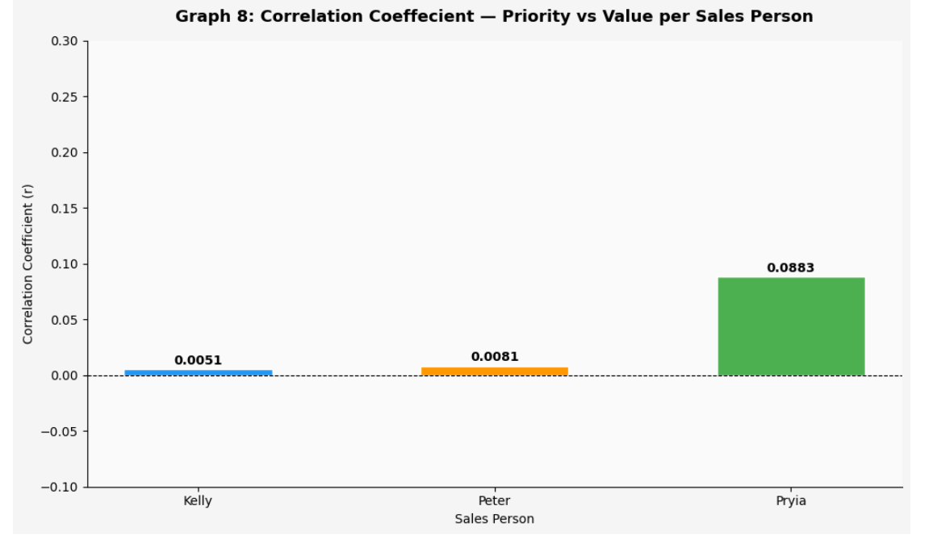
The Correlation Coefficient is used measure the strength and direction of a linear relationship between two numerical variables. It produces a value between -1 and +1, where values close to +1 indicate a strong positive relationship, values close to -1 indicate a strong negative relationship, and values close to 0 indicate no meaningful linear relationship. The overall Correlation between priority numeric and value_£ across the entire dataset was calculated at r = 0.0312, which is classified as a very weak positive correlation and is effectively negligible. When broken down by sales representative, Kelly returns r = 0.0045, Peter returns r = -0.0002, and Pryia returns r = 0.0815. With all three values being extremely close to zero, confirming that for none of them, the priority level does not have a meaningful effect on the value of a sale. This is a conclusive and important finding for the sales manager.

Figure 9: Graph 9: Spearman's Rank Correlation - Priority vs. Value per Sales Person
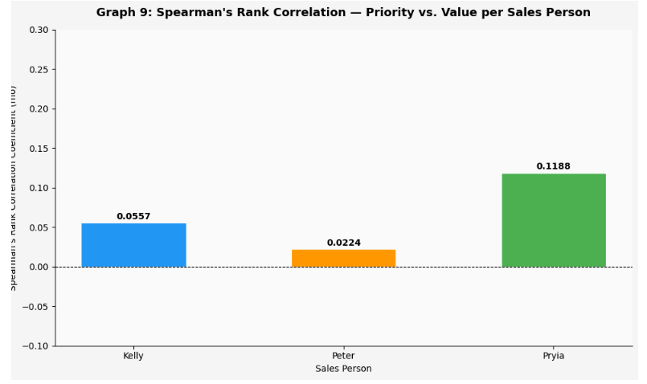

Pearson correlation assumes linearity and is best suited for interval data. Since priority is ordinal, Spearman's rank correlation (rho) is more appropriate as it assesses monotonic relationships using ranked data (Spearman, 1904).
Graph 9 presents the Spearman results alongside Graph 8. The conclusion remains consistent — a very weak positive relationship between priority and sale value across all three representatives. Pryia shows the strongest correlation under both measures. The agreement between both methods strengthens the reliability of this finding.

Reflection and Limitations
This project developed my practical ability to apply Python independently to a real dataset, strengthening my understanding of how programming logic and analytical decisions interact. Working with pandas and matplotlib across a multi-step pipeline built confidence in procedural programming for data analysis.
The main challenge was handling the priority variable — initially encoding "Not Specified" distorted the correlation results, which was resolved by removing it at the pre-processing stage. Choosing between Pearson and Spearman also required critical evaluation, with both ultimately being used to strengthen the finding.
Python proved effective for automating reproducible analysis pipelines, however matplotlib requires significant manual effort for styling. Tools such as Seaborn or Plotly would be more efficient for visualisation in future projects.
Limitations include the six-month dataset restricting generalisability of trends, analysis being confined to three variables, and correlation being unable to establish causation or capture non-linear relationships.
Conclusion
This report has delivered a comprehensive exploratory data analysis of the One Time Sales and Marketing Ltd sales dataset for the period June to November 2020. Pryia is the strongest performer, accounting for 38% of total revenue and consistently outperforming her colleagues across the latter half of the study period. Peter, despite the highest transaction volume, records the lowest average sale value, suggesting a need for targeted coaching on upselling, reallocation to higher-value accounts, and support in identifying higher-value customer opportunities. Both Pearson and Spearman correlation tests confirm no meaningful relationship between priority level and sale value across all three representatives, meaning priority should not be used as a standalone forecasting variable. The business should act on these findings by reviewing Pryia's sales approach and sharing her techniques as a team benchmark, providing Peter with structured support in targeting higher-value customers, establishing monthly performance monitoring aligned with the seasonal patterns observed, and exploring additional variables such as customer profile and product type to build a more robust predictive framework.

References
Field, A. (2018) Discovering Statistics Using IBM SPSS Statistics. 5th edn. London: SAGE Publications.
Han, J., Kamber, M. and Pei, J. (2011) Data Mining: Concepts and Techniques. 3rd edn. Burlington: Morgan Kaufmann.
Hunter, J.D. (2007) 'Matplotlib: A 2D graphics environment', Computing in Science and Engineering, 9(3), pp. 90-95.
McKinney, W. (2010) 'Data structures for statistical computing in Python', Proceedings of the 9th Python in Science Conference, 445, pp. 51-56.
Pearson, K. (1895) 'Notes on regression and inheritance in the case of two parents', Proceedings of the Royal Society of London, 58, pp. 240-242.
Spearman, C. (1904) 'The proof and measurement of association between two things', The American Journal of Psychology, 15(1), pp. 72-101.
Tukey, J.W. (1977) Exploratory Data Analysis. Reading, MA: Addison-Wesley.

Appendix / Code Evidence Section
#Initial Process Started:

import pandas as pd
import numpy as np

# STEP 1: Import the dataset
df = pd.read_excel('/content/Sales Data_PDA_4052.xlsx', header=1)

# STEP 2: Correct data types
df['order_id'] = df['order_id'].astype(int)
df['customer_id'] = df['customer_id'].astype(str)
df['sales_person'] = df['sales_person'].astype(str)
df['priority'] = pd.Categorical(df['priority'],
categories=['Low', 'Medium', 'High', 'Critical'],
ordered=True)
df['ship_mode'] = df['ship_mode'].astype(str)
df['date'] = pd.to_datetime(df['date'])
df['value_£'] = df['value_£'].astype(float)

# STEP 3: Data types result
print("--- COLUMN DATA TYPES ---")
print(df.dtypes)

# STEP 4: Dataset shape and preview
print("\n--- DATASET SHAPE ---")
print(f"Rows: {df.shape[0]} | Columns: {df.shape[1]}")
print("\n--- FIRST 5 ROWS ---")
print(df.head())

# STEP 5: Missing values
print("\n--- MISSING VALUES ---")
print(df.isnull().sum())

# STEP 6: Date range - Converting datetime value into a readable text format
print("\n--- DATE RANGE ---")
print(f"Start : {df['date'].min().strftime('%d %B %Y')}")
print(f"End : {df['date'].max().strftime('%d %B %Y')}")

# STEP 7: Categorical summaries
print("\n--- SALES PERSONS ---")
print(df['sales_person'].value_counts())

print("\n--- PRIORITY BREAKDOWN ---")
print(df['priority'].value_counts().sort_index())

print("\n--- SHIP MODE BREAKDOWN ---")
print(df['ship_mode'].value_counts())

# STEP 8: Statistical summary on value_£
v = df['value_£']
print("\n--- STATISTICAL SUMMARY: value_£ ---")
print(f" Count : {v.count()}")
print(f" Mean : £{v.mean():,.2f}")
print(f" Median : £{v.median():,.2f}")
print(f" Mode : £{v.mode()[0]:,.2f}")
print(f" Std Dev : £{v.std():,.2f}")
print(f" Variance : £{v.var():,.2f}")
print(f" Min : £{v.min():,.2f}")
print(f" Max : £{v.max():,.2f}")
print(f" Range : £{v.max() - v.min():,.2f}")
print(f" Q1 (25%) : £{v.quantile(0.25):,.2f}")
print(f" Q3 (75%) : £{v.quantile(0.75):,.2f}")
print(f" IQR : £{v.quantile(0.75) - v.quantile(0.25):,.2f}")
print(f" Skewness : {v.skew():.4f}")
print(f" Kurtosis : {v.kurt():.4f}")

# STEP 9: Stats by sales person
print("\n--- SALES VALUE STATS BY SALES PERSON ---")
print(df.groupby('sales_person')['value_£'].agg(
Count='count',
Total=lambda x: round(x.sum(), 2),
Mean=lambda x: round(x.mean(), 2),
Median='median',
Std=lambda x: round(x.std(), 2),
Min='min',
Max='max'
).to_string())

# STEP 10: Stats by priority
print("\n--- SALES VALUE STATS BY PRIORITY ---")
print(df.groupby('priority', observed=False)['value_£'].agg(
Count='count',
Total=lambda x: round(x.sum(), 2),
Mean=lambda x: round(x.mean(), 2),
Median='median',
Std=lambda x: round(x.std(), 2)
).to_string())

# Now Performing PRE-PROCESSING:

# STEP 1: Check for duplicates
print("--- DUPLICATE ROWS ---")
print(f"Total duplicates found: {df.duplicated().sum()}")
df = df.drop_duplicates()
print(f"Rows after removing duplicates: {len(df)}")

# STEP 2: Check for outliers in value_£ using Interquartile Range (IQR) Method

print("\n--- OUTLIER DETECTION (IQR Method) on value_£ ---")
Q1 = df['value_£'].quantile(0.25)
Q3 = df['value_£'].quantile(0.75)
IQR = Q3 - Q1
lower_bound = Q1 - 1.5 * IQR
upper_bound = Q3 + 1.5 * IQR

#checking if lower OR upper bound

outliers = df[(df['value_£'] < lower_bound) | (df['value_£'] > upper_bound)]
print(f"Lower Bound : £{lower_bound:,.2f}")
print(f"Upper Bound : £{upper_bound:,.2f}")
print(f"Outliers found: {len(outliers)}")
print(outliers[['order_id', 'sales_person', 'priority', 'date', 'value_£']].to_string())

# STEP 3: Encode priority as numeric for correlation study
print("\n--- ENCODING PRIORITY AS NUMERIC ---")
priority_map = {
'Low' : 1,
'Medium' : 2,
'High' : 3,
'Critical' : 4
}
df['priority_numeric'] = df['priority'].map(priority_map)
print("Priority mapping applied:")
print(df[['priority', 'priority_numeric']].drop_duplicates().sort_values('priority_numeric').to_string(index=False))

# STEP 4: Extract time features from date
print("\n--- EXTRACTING TIME FEATURES FROM DATE ---")
df['month'] = df['date'].dt.month
df['month_name'] = df['date'].dt.strftime('%B')
df['week'] = df['date'].dt.isocalendar().week.astype(int)
print("Month and week columns added.")
print(df[['date', 'month', 'month_name', 'week']].head(5).to_string(index=False))

# STEP 5: Normalise value_£ (Min-Max scaling)
print("\n--- NORMALISING value_£ (Min-Max Scaling) ---")
df['value_normalised'] = (df['value_£'] - df['value_£'].min()) / (df['value_£'].max() - df['value_£'].min())
print(f" Original — Min: £{df['value_£'].min():,.2f} Max: £{df['value_£'].max():,.2f}")
print(f" Normalised — Min: {df['value_normalised'].min():.4f} Max: {df['value_normalised'].max():.4f}")

# STEP 6: BEFORE vs AFTER comparison
print("\n--- BEFORE vs AFTER PRE-PROCESSING ---")
print(f" {'Metric':<30} {'Before':>12} {'After':>12}")
print(f" {'-'*54}")
print(f" {'Total Rows':<30} {'1001':>12} {len(df):>12}")
print(f" {'Duplicate Rows':<30} {'1':>12} {'0':>12}")
print(f" {'Columns':<30} {'7':>12} {len(df.columns):>12}")
print(f" {'Priority Encoded':<30} {'No':>12} {'Yes':>12}")
print(f" {'Time Features Extracted':<30} {'No':>12} {'Yes':>12}")
print(f" {'Value Normalised':<30} {'No':>12} {'Yes':>12}")
print(f" {'Outliers Identified':<30} {'No':>12} {'Yes':>12}")
# STEP 7: Final dataset shape and preview
print("\n--- FINAL DATASET PREVIEW ---")
print(f"Shape: {df.shape[0]} rows | {df.shape[1]} columns")
print(df.head())

print("\n--- UPDATED COLUMN LIST ---")
print(df.columns.tolist())

# --- Making the Data Ready to Make Graphs for Visual Representations ---

import pandas as pd
import numpy as np
import matplotlib.pyplot as plt
import matplotlib.ticker as mticker

df = pd.read_excel('/content/Sales Data_PDA_4052.xlsx', header=1)

df['order_id'] = df['order_id'].astype(int)
df['customer_id'] = df['customer_id'].astype(str)
df['sales_person'] = df['sales_person'].astype(str)
df['priority'] = pd.Categorical(df['priority'],
categories=['Low','Medium', 'High','Critical'],
ordered=True)
df['ship_mode'] = df['ship_mode'].astype(str)
df['date'] = pd.to_datetime(df['date'])
df['value_£'] = df['value_£'].astype(float)

df = df.drop_duplicates()

priority_map = {'Low':1,'Medium':2, 'High':3,'Critical':4}
df['priority_numeric'] = df['priority'].map(priority_map)
df['month'] = df['date'].dt.month
df['month_name'] = df['date'].dt.strftime('%B')
df['week'] = df['date'].dt.isocalendar().week.astype(int)
df['value_normalised'] = (df['value_£'] - df['value_£'].min()) / \
(df['value_£'].max() - df['value_£'].min())

colours = {'Kelly':'#2196F3','Peter':'#FF9800','Pryia':'#4CAF50'}
priority_cols = ['#81C784','#64B5F6','#FF8A65','#E57373']
month_order = ['June','July','August','September','October','November']
monthly = df.groupby(['month_name','sales_person'])['value_£'].sum().reset_index()

print("Data ready.")

# Graph 1 Preparation and Creation

fig1, ax1 = plt.subplots(figsize=(10, 6))
fig1.patch.set_facecolor('#F5F5F5')

totals = df.groupby('sales_person')['value_£'].sum().sort_values(ascending=False)
bars = ax1.bar(totals.index, totals.values,
color=[colours[n] for n in totals.index], edgecolor='white', width=0.5)
for bar, val in zip(bars, totals.values):
ax1.text(bar.get_x() + bar.get_width()/2, bar.get_height() + 5000,
f'£{val:,.0f}', ha='center', va='bottom', fontsize=10, fontweight='bold')

ax1.set_title('Graph 1: Total Sales Value per Sales Person', fontweight='bold', pad=15, fontsize=13)
ax1.set_ylabel('Total Sales (£)')
ax1.set_xlabel('Sales Person')
ax1.yaxis.set_major_formatter(mticker.FuncFormatter(lambda x, _: f'£{x:,.0f}'))
ax1.set_facecolor('#FAFAFA')
ax1.spines['top'].set_visible(False)
ax1.spines['right'].set_visible(False)

plt.tight_layout()
plt.show()

# Graph 2 Preparation and Creation

fig2, ax2 = plt.subplots(figsize=(10, 6))
fig2.patch.set_facecolor('#F5F5F5')

totals = df.groupby('sales_person')['value_£'].sum().sort_values(ascending=False)
ax2.pie(totals.values,
labels=totals.index,
autopct='%1.1f%%',
colors=[colours[n] for n in totals.index],
startangle=140,
wedgeprops={'edgecolor':'white','linewidth':2})

ax2.set_title("Graph 2: Each Sales Person's Share of Total Revenue",
fontweight='bold', pad=15, fontsize=13)

plt.tight_layout()
plt.show()

# Graph 3 Preparation and Creation

fig3, ax3 = plt.subplots(figsize=(12, 6))
fig3.patch.set_facecolor('#F5F5F5')

for person, grp in monthly.groupby('sales_person'):
grp = grp.set_index('month_name').reindex(month_order)
ax3.plot(month_order, grp['value_£'].values,
marker='o', linewidth=2.5, markersize=7,
label=person, color=colours[person])
for i, val in enumerate(grp['value_£'].values):
if not np.isnan(val):
ax3.annotate(f'£{val:,.0f}',
xy=(i, val), xytext=(0, 10),
textcoords='offset points',
ha='center', fontsize=8)

ax3.set_title('Graph 3: Monthly Sales Trend per Sales Person',
fontweight='bold', pad=15, fontsize=13)
ax3.set_ylabel('Total Sales (£)')
ax3.set_xlabel('Month')
ax3.yaxis.set_major_formatter(mticker.FuncFormatter(lambda x, _: f'£{x:,.0f}'))
ax3.legend(title='Sales Person')
ax3.set_facecolor('#FAFAFA')
ax3.spines['top'].set_visible(False)
ax3.spines['right'].set_visible(False)

plt.tight_layout()
plt.show()

# Graph 4 Preparation and Creation

fig4, ax4 = plt.subplots(figsize=(12, 6))
fig4.patch.set_facecolor('#F5F5F5')

persons = ['Kelly','Peter','Pryia']
x = np.arange(len(month_order))
width = 0.25

for i, person in enumerate(persons):
vals = []
for m in month_order:
row = monthly[(monthly['sales_person']==person) & (monthly['month_name']==m)]
vals.append(row['value_£'].values[0] if len(row) > 0 else 0)
ax4.bar(x + i*width, vals, width=width,
label=person, color=colours[person], edgecolor='white')

ax4.set_title('Graph 4: Monthly Sales Comparison per Sales Person (Grouped Bar)',
fontweight='bold', pad=15, fontsize=13)
ax4.set_ylabel('Total Sales (£)')
ax4.set_xlabel('Month')
ax4.set_xticks(x + width)
ax4.set_xticklabels(month_order)
ax4.yaxis.set_major_formatter(mticker.FuncFormatter(lambda x, _: f'£{x:,.0f}'))
ax4.legend(title='Sales Person')
ax4.set_facecolor('#FAFAFA')
ax4.spines['top'].set_visible(False)
ax4.spines['right'].set_visible(False)

plt.tight_layout()
plt.show()

# Graph 5 Preparation and Creation

fig5, ax5 = plt.subplots(figsize=(10, 6))
fig5.patch.set_facecolor('#F5F5F5')

priority_avg = df.groupby('priority', observed=False)['value_£'].mean()
bars5 = ax5.bar(priority_avg.index.astype(str), priority_avg.values,
color=priority_cols, edgecolor='white', width=0.5)
for bar, val in zip(bars5, priority_avg.values):
ax5.text(bar.get_x() + bar.get_width()/2, bar.get_height() + 20,
f'£{val:,.0f}', ha='center', va='bottom', fontsize=10, fontweight='bold')

ax5.set_title('Graph 5: Average Sale Value by Priority',
fontweight='bold', pad=15, fontsize=13)
ax5.set_ylabel('Average Value (£)')
ax5.set_xlabel('Priority Level')
ax5.yaxis.set_major_formatter(mticker.FuncFormatter(lambda x, _: f'£{x:,.0f}'))
ax5.set_facecolor('#FAFAFA')
ax5.spines['top'].set_visible(False)
ax5.spines['right'].set_visible(False)

plt.tight_layout()
plt.show()

# Graph 6 Preparation and Creation

fig6, ax6 = plt.subplots(figsize=(10, 6))
fig6.patch.set_facecolor('#F5F5F5')

priority_levels = ['Low','Medium', 'High','Critical']
box_data = [df[df['priority']==p]['value_£'].values for p in priority_levels]
bp = ax6.boxplot(box_data, patch_artist=True, tick_labels=priority_levels,
medianprops=dict(color='black', linewidth=2))
for patch, colour in zip(bp['boxes'], priority_cols):
patch.set_facecolor(colour)

ax6.set_title('Graph 6: Sale Value Distribution by Priority (Box Plot)',
fontweight='bold', pad=15, fontsize=13)
ax6.set_ylabel('Sale Value (£)')
ax6.set_xlabel('Priority Level')
ax6.yaxis.set_major_formatter(mticker.FuncFormatter(lambda x, _: f'£{x:,.0f}'))
ax6.set_facecolor('#FAFAFA')
ax6.spines['top'].set_visible(False)
ax6.spines['right'].set_visible(False)

plt.tight_layout()
plt.show()

# Graph 7 Preparation and Creation

fig7, ax7 = plt.subplots(figsize=(10, 6))
fig7.patch.set_facecolor('#F5F5F5')

for person, grp in df.groupby('sales_person'):
ax7.scatter(grp['priority_numeric'], grp['value_£'],
label=person, alpha=0.5, s=30, color=colours[person])

# Filter out NaN values before performing polyfit
df_filtered = df.dropna(subset=['priority_numeric', 'value_£'])
m, b = np.polyfit(df_filtered['priority_numeric'], df_filtered['value_£'], 1)
x_line = np.linspace(1, 4, 100)
ax7.plot(x_line, m*x_line + b, color='black', linewidth=2,
linestyle='--', label=f'Trend (slope={m:.1f})')

ax7.set_title('Graph 7: Priority vs Sale Value (Scatter + Trend Line)',
fontweight='bold', pad=15, fontsize=13)
ax7.set_xlabel('Priority (1=Low → 4=Critical)') # Updated label
ax7.set_ylabel('Sale Value (£)')
ax7.set_xticks([1,2,3,4])
ax7.set_xticklabels(['Low','Medium','High','Critical'])
ax7.yaxis.set_major_formatter(mticker.FuncFormatter(lambda x, _: f'£{x:,.0f}'))
ax7.legend(fontsize=9)
ax7.set_facecolor('#FAFAFA')
ax7.spines['top'].set_visible(False)
ax7.spines['right'].set_visible(False)

plt.tight_layout()
plt.show()

# Graph 8 Preparation and Creation

fig8, ax8 = plt.subplots(figsize=(10, 6))
fig8.patch.set_facecolor('#F5F5F5')

corr_by_person = df.groupby('sales_person').apply(
lambda g: g['priority_numeric'].corr(g['value_£'])
).reset_index()
corr_by_person.columns = ['Sales Person', 'Correlation']
bar_cols = [colours[p] for p in corr_by_person['Sales Person']]

bars8 = ax8.bar(corr_by_person['Sales Person'], corr_by_person['Correlation'],
color=bar_cols, edgecolor='white', width=0.5)
for bar, val in zip(bars8, corr_by_person['Correlation']):
ax8.text(bar.get_x() + bar.get_width()/2,
bar.get_height() + 0.002,
f'{val:.4f}', ha='center', va='bottom', fontsize=10, fontweight='bold')

ax8.axhline(0, color='black', linewidth=0.8, linestyle='--')
ax8.set_title('Graph 8: Correlation Coeffecient — Priority vs Value per Sales Person',
fontweight='bold', pad=15, fontsize=13)
ax8.set_ylabel('Correlation Coefficient (r)')
ax8.set_xlabel('Sales Person')
ax8.set_ylim(-0.1, 0.3)
ax8.set_facecolor('#FAFAFA')
ax8.spines['top'].set_visible(False)
ax8.spines['right'].set_visible(False)

plt.tight_layout()
plt.show()

# Graph 9 Preparation and Creation of Spearman's Rank Correlation

fig9, ax9 = plt.subplots(figsize=(10, 6))
fig9.patch.set_facecolor('#F5F5F5')

spearman_corr_by_person = df.groupby('sales_person').apply(
lambda g: g['priority_numeric'].corr(g['value_£'], method='spearman')
).reset_index()
spearman_corr_by_person.columns = ['Sales Person', 'Spearman_Correlation']
bar_cols_spearman = [colours[p] for p in spearman_corr_by_person['Sales Person']]

bars9 = ax9.bar(spearman_corr_by_person['Sales Person'], spearman_corr_by_person['Spearman_Correlation'],
color=bar_cols_spearman, edgecolor='white', width=0.5)
for bar, val in zip(bars9, spearman_corr_by_person['Spearman_Correlation']):
ax9.text(bar.get_x() + bar.get_width()/2,
bar.get_height() + 0.002,
f'{val:.4f}', ha='center', va='bottom', fontsize=10, fontweight='bold')

ax9.axhline(0, color='black', linewidth=0.8, linestyle='--')
ax9.set_title('Graph 9: Spearman\'s Rank Correlation — Priority vs. Value per Sales Person',
fontweight='bold', pad=15, fontsize=13)
ax9.set_ylabel('Spearman\'s Rank Correlation Coefficient (rho)')
ax9.set_xlabel('Sales Person')
ax9.set_ylim(-0.1, 0.3) # Keep consistent y-limit for comparison with Pearson
ax9.set_facecolor('#FAFAFA')
ax9.spines['top'].set_visible(False)
ax9.spines['right'].set_visible(False)

plt.tight_layout()
plt.show()

